**Popular Applications – Frontend & Backend Components**

**1. Flipkart**

Flipkart utilizes a combination of technologies for its frontend and backend

**Frontend components:**

**• React.JS:** forbuilding the user interface and ensuring dynamic, responsive pages.

•**Redux:** for managing the applications state.

•**HTML, CSS, JavaScript:** The core technologies for web development, ensuring a responsive design.

**Backend Components:**

**•Node.js and Express.js:** For server-side programming and creating robust APIs.

•**Java:** primary backend language.

•**Python:** Used in data analytics and machine learning applications.

•**MySQL/MongoDB**: For database management.

**PROCEDURE:**

To effectively use the flipkart app, first download and install it, then create an account, explore the home screen, browse products, add items to your cart and complete your purchase by providing address and payment details.

Step by step procedure of users used application.

1.First download and install the flipchart app

Go to the google play store Android or IOS search for “flip kart”.

Download and install the app on device.

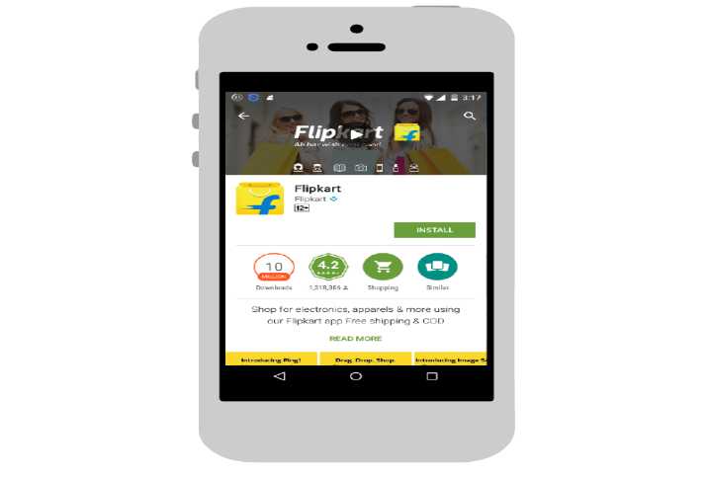

2.Create an account

Open the flipkart app and sign up with mail id or linking facebook or google account. You can choose to one sign up with phone number

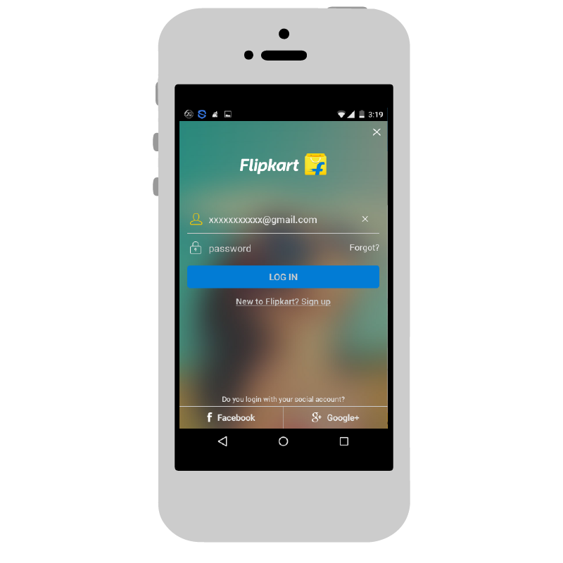

3.Explore the homescreen

The homescreen features deals ,offers,recommendations and popular products across different categories.

Scroll down to explore various sections like offerzone, deals of the day and other categories.

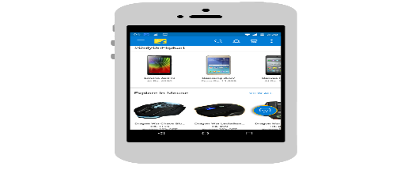

4.Browse products:

Use to search bar to find specific products or browse through different categories.click on a product to view its details,price,specifications and customer reviews.

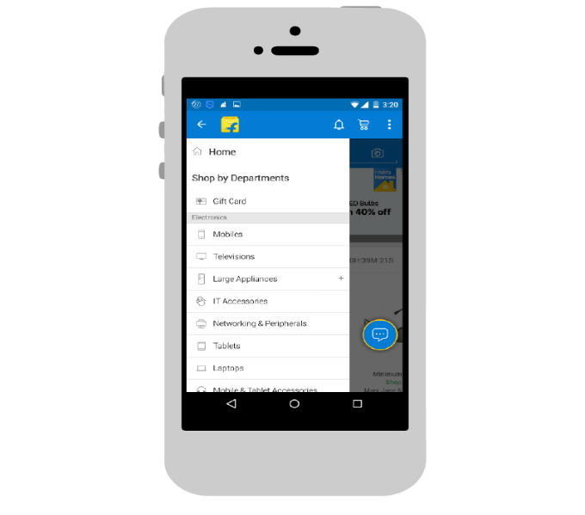

5.Adding products to cart and making a purchase:

Add to cart,Review cart,checkout,payment,place order and

Other features are fast deliveries within certain areas,Access customer support for any issues and queries.

**2.CRICBUZZ:**

Cricbuzz uses the following technologies to deliver realtime cricket scores and updates.

**Frontend Components:**

**•HTML,CSS,JavaScript:** For a responsive Design.

•**React.js & Angular.js:** For building a dynamic and fast-loading frontend

**•Bootstrap &Material UI:** For a user-friendly interface

•**WebSockets**: Enables real-time updates on the client side.

**Backend Components:**

**•Java:** The primary backend language.

**•Spring Boot:** For Creating scalable microservices.

**•Node.js:** For handling a synchronous requests and real-time updates.

**•Python:** Used in data analytics and machine learning applications.

**•Redis & Memcached:** For fast caching and retrieval of frequently accessed data.

**Procedure:**

Use the cricbuzz app, first need to download and install it on device, create an account. Once logged in can explore features like live scores,news and video content.

Step by step users use the application

1.first open the app (Google play store,app store for IOS) in the device and search for “cricbuzz”, download and install the app.

2.after open the cric buzz app, register to create an account and after entering the email address, create password and any other information and verify email address.

3.Explore the features like live scores, news and articles, video content, player stats and Rankings, upcoming matches, user interaction



**3.Abhi Bus:**

**Frontend Components:**

**• React, Angular or Vue.js :** For building the user interface

•**JavaScript, Html&CSS**: Core frontend Technologies.

**Backend Components:**

**•Node.js & Express .js:** For developing and maintaining backend services.

•**MySQL, MongoDB &Cassandra**: For data base management.

•**Kafka**: For messaging systems and real time communication.

**Procedure**:

To book bus tickets on abhi bus app, start by opening the app and entering your origin and destination cities, along with the travel date. Search for available buses and select preferred operator and seat. Choose boarding and dropping points, then enter passenger details and payment information to complete the booking.

Step by step users used by application

1.first download and install open abhi bus app on mobile device.

2.Enter trip details are origin city and destination city with travel date .

3.searching for buses find available bus routes for journey

4.use abhibus smart filters to refine search based on preferences like AC/NON AC,sleeper,price,departure time.

5.choose the preferred seat from available seating options.

6.enter passenger details are names,ages,contact information

7.apply coupon codes to get discounts

8.after proceed to pay finalize booking choose preferred payment method credit card,debit card,net banking,etc

9.upon successful payment,receive an sms/whatsapp and ticket as confirmation, after journey passengers to rating the service.